Dungannon
Primary School

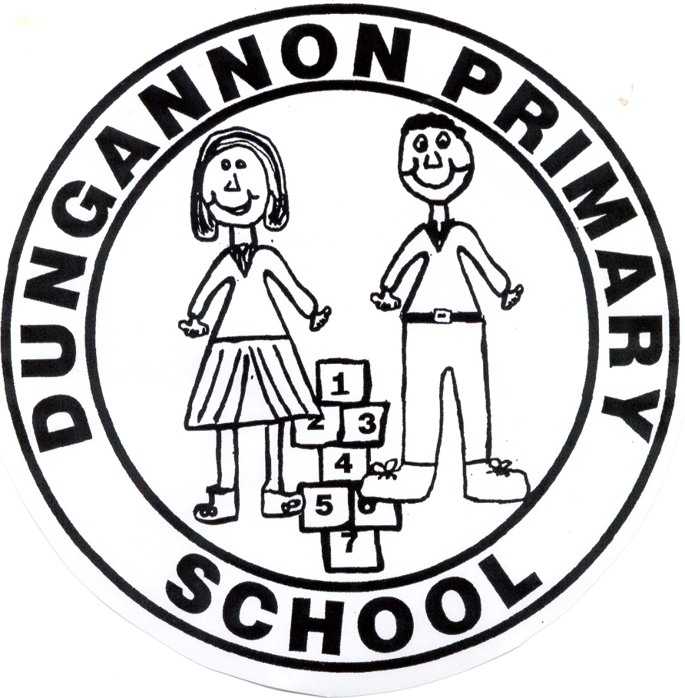

Positive Behaviour
Policy

Reviewed
June 2023
INTRODUCTION

Children attending Dungannon Primary School are expected to maintain a high standard of behaviour as reported by the Department of Education and Training Inspectorate - 2008/09

“The children are well mannered, friendly and courteous; their behaviour is exemplary”.

AIMS

This positive behaviour policy aims to:-

- Establish a community wherein pupils, teachers, parents and support staff are valued and enjoy a sense of belonging

- Create an acceptable level of order and behaviour so that effective teaching and learning can take place.

- Help all our pupils to realise their potential in their physical, intellectual, social and personal development.

- Encourage self respect, self discipline, respect for others and property in the school and community.

- Ensure that parents are informed of our disciplinary policy procedures and to encourage their co-operation and support in the successful implementation of our school discipline policy.

INTRODUCTION TO BEHAVIOUR MANAGEMENT

The Principal and Staff at this school believe firmly that effective learning cannot take place without a requisite standard of good behaviour. In the context of this school, good behaviour is defined as conduct which assists the school to fulfil its function, namely the full development of the potential of all its pupils. Conversely, bad behaviour would be defined as conduct which prevents this, either when an individual prevents his/her own development by behaving badly or when unacceptable conducts disrupts the development process for other members of the community.

It therefore follows that good behaviour is that which conforms to the reasonable expectations and requirements of the school and is based upon mutual respect for the needs and aspirations of all in the school and upon care for its environment.

A POSITIVE APPROACH

Whilst this policy outlines sanctions which may be imposed as necessary, we do not see discipline within our school as a series of rules and regulations. Rather we view discipline in a positive way, where praise and reward are fundamental. It is our desire to cultivate in pupils an acceptance and recognition for their own decisions, their actions and consequences. We hope to train and guide children to behave in a socially acceptable way whilst in the care of teachers and others in the education process.
ROLES WITHIN OUR SCHOOL POSITIVE BEHAVIOUR POLICY

Rights and Responsibilities of Pupils
We would expect the children who attend Dungannon Primary School to enjoy their education and to have their needs met. However, at the same time, we wish to encourage children to realise that other children deserve and must enjoy the same treatment as they do. A child who is experiencing difficulty at school should inform his/her class teacher, the Principal or any other member of school staff.

Pupils have a right to:
- Work and play in a calm and safe environment.
- Receive a broad and balanced curriculum
- Be listened to in a sensitive manner.
- Be made aware of the school’s standard of expectations with regard to work and discipline.
- A fair, consistent, clear and calm approach to discipline.

Pupils have a responsibility to:
- Follow the school’s code of conduct contained in the Positive Behaviour Policy including rules relating to attendance, punctuality and uniform.
- Show respect for staff, visitors and other pupils in school.
- Show respect for their own and other’s property.
- Behave in an acceptable manner in class and in the playground.
- Listen attentively in class and work to the best of their ability.
- Follow the directions of staff, both teaching and non-teaching.
- Represent the school in a positive way.

As a Rights Respecting School we adhere to the following UNCRC Articles:
- UNCRC Article 2: Rights apply to every child without discrimination
- UNCRC Article 3: Everyone who works with children should do what is best for each child
- UNCRC Article 36: Every child has the right to be protected from things that could harm them
- UNCRC Article 19: Every child has the right not to be harmed; they should be looked after and kept safe

Role of Parents/Guardians
Standards of behaviour are well established in children before they come to school. The accepted standards of behaviour may vary from home to home and family to family. Behaviour which can be tolerated at home may not always be acceptable at school because of the large numbers involved in the school community.

We believe in the principle of partnership and therefore encourage parents and guardians to establish and maintain a relationship with the class teacher and Principal.

Active co-operation with staff is absolutely essential if an acceptable standard of discipline is to be achieved.

The co-operation of parents is sought in relation to maintaining high standards of pupil attendance, punctuality, pupil appearance, wearing the school uniform, caring for learning materials (particularly those belonging to the school) and supervision of homework.

Rights and Responsibilities of Parents and Guardians

Parents have a right to expect:
- A safe and happy learning environment for their child.
- Up to date information on the school POSITIVE BEHAVIOUR policy and procedures.
- To be kept informed should their child not meet the standards of discipline set.
- An opportunity to discuss disciplinary matters with the class teacher or Principal including sanctions imposed in accordance with policy procedures.
- A consistent and fair approach to discipline with punishment commensurate with the seriousness of the misdemeanour.
- A school community which is sensitive to the needs of the individual child.
- An acceptable level of courtesy and respect to be shown to their children by staff.

Parents have a responsibility to:
- Promote an understanding of what is acceptable and unacceptable in terms of behaviour.
- Advise school at the earliest opportunity of any problems concerning their child.
- Support the school in implementing the discipline policy and in maintaining a high standard of discipline.
- Ensure that children comply with school rules regarding uniform, attendance and punctuality.
- Encourage children to show respect to all staff, school visitors and peers.
- Encourage children to value their own property, school property and that of others.
- Encourage children to complete school work and homework to an acceptable level.
- Work in conjunction with the teachers and Principal should any discipline be required.

ROLE OF THE TEACHER

A teacher’s role is to provide education for the children in his/her care. When the teacher and pupil understand their different roles positive behaviour can be achieved. Children at different stages in education require instructions and our school rules form the framework of the expectations we have for the children in our care. Our rules will be clearly displayed in each classroom and commented on, at regular intervals, by the teacher. Teachers will encourage good behaviour within their class in a positive manner having regard to the positive nature of our school policy, consulting with senior management and the Principal when necessary.

Rights and Responsibilities of Teachers

Teachers have a right to:
- Expect opportunities for professional development.
- Be valued as part of the school team.
- Work in a safe environment
- Manage the behaviour of all pupils according to school procedures.
- Expect back up procedures to be in place for managing behaviour.
- Expect courtesy and respect from colleagues, parents and pupils.
- Have an opportunity to work to their full potential in a calm environment.

Teachers have a responsibility to:
- Provide children with a broad and balanced curriculum.
- Implement the school’s Positive Behaviour Policy in a fair and consistent manner.
- Recognise the individuality of children and strive to cater for their needs.
- Consult with parents about a child’s progress or behaviour.
- Provide a safe working environment in the classroom, where all children can work effectively to the best of their ability.
- Co-operate and work with the school management team and colleagues.

ROLE OF THE PRINCIPAL

The Principal has a key role in formulating and reviewing the Positive Behaviour Policy and establishing the ethos of the school. He must ensure that teachers, pupils and parents play a vital role in the life and organisation of the school.

The Principal must ensure that the rules of the school are administered fairly and consistently to all pupils. He should support his staff where appropriate and furnish Board of Governors and the Education Authority (if necessary) with a report on the discipline within the school or on the discipline of an individual pupil where necessary.

The Principal must also ensure that the school Positive Behaviour Policy is processed in accordance and alongside all other relevant school policies ie SEN Policy, Pastoral Care Policy, Anti-Bulling Policy and Code of Practice, etc.

ROLE OF THE BOARD OF GOVERNORS

The role of the Board of Governors is to maintain a Positive Behaviour Policy for the school which is current, being implemented, positive in nature and reflective of the school ethos.

If or when a case of indiscipline should come before them they must act upon it having considered the views of the Principal, other interested parties and any reports forwarded to them.

Where appropriate they should support the Principal and his teaching staff.

PUPIL’S CODE OF CONDUCT

A very high standard of conduct, work and appearance is expected from each boy and girl who is a pupil at Dungannon Primary School. Respect for oneself and consideration for others are the ideals by which pupils should be guided in all their behaviour in school, in the home and in the wider community.

The Code of Conduct is very important in ensure that you can reach your full potential at Dungannon Primary School.

Attendance
- Regular attendance is essential.
- The school day is from 8.50am to 2.00 pm or 3.00 pm.
- No pupil may leave school without the permission of his/her teacher or Principal on receipt of a note.

Punctuality
- Children should be on the school premises by 8.30 am at the earliest when teacher supervision is available. (8:00am if attending Breakfast Club)
- Parents should ensure that children are collected promptly at 2.00 pm, 3.00 pm or after school club finishing time.
- Parents are asked to drive carefully within the school grounds and to follow the instructions of members of staff.

Behaviour
- Pupils should have respect for themselves and others and take responsibility for their own actions.
- Pupils should be always well mannered especially in the presence of other adults.
- The use of bad language and gesture is unacceptable. Boisterous games and activities which are liable to cause injury to the pupils or others are prohibited. Teachers and supervisors are to be obeyed at all times.

Appearance
- A high standard of personal appearance is expected at all times.
- Full uniform should be worn at all times unless previously arranged with class teacher/Principal.
- For safety reasons, jewellery will be restricted to a watch. When engaged in physical activities it may be necessary to remove jewellery which may cause danger. If earrings must be worn they should be studs. Your child must be able to remove them for P.E. After six weeks of piercing, all earrings must be removed.

Movement
- Pupils should move around the school in a quiet and orderly manner as directed in the School Rules.
- Pupils will walk on the left hand side of corridors and stairs.
- Toilets should be used at the set times or when otherwise directed by the teacher.
- In the dining hall, pupils are expected to walk in an orderly manner when entering, exiting or moving within the hall.

Property
- It is expected that all pupils will show due care and respect for their own and other’s property. School property and school grounds are due the same importance as something which is your own.
- Pupil’s names should be clearly marked on all clothing and articles brought into school. Pupils should only bring into school items of property which they need or are asked to bring by their class teacher.

PUPILS ARE RESPONSIBLE FOR THEIR OWN BEHAVIOUR

Expected behaviour in:

The Playground –
In the playground, children should abide by the following rules:
- In dry weather, children should be outside at break and lunch-time.
- Pupils should not use unacceptable language and gestures.
- Pupils should not climb trees, fences or hedges in school grounds.
- Children must not throw stones or other missiles.
- Boisterous games and activities which are liable to cause injury to the pupil or others are prohibited.
- Teachers and supervisors should be obeyed at all times.
- Equipment is to be used in a safe and acceptable manner.
- Children must remain in the main playground area.

THE DINING HALL

In the dining hall children should abide by the following rules:-
- Children should enter the dinner hall quietly in single file.
- Stand quietly in the line when approaching the dinner hatch.
- Stand quietly in the line and remember to say ‘please’ and ‘thank you’.
- Walk one way only around the hall.
- When you are finished eating, place your knife and fork in the middle of your plate or put your spoon into your bowl.
- Place your plate in the middle of the table.
- Walk quietly out of the hall when directed by an adult.

EDUCATIONAL VISITS

Pupils on school visits will be expected to abide by the aims of our school Positive Behaviour Policy and school rules re behaviour.

In addition the Principal and staff will reserve the right to implement any rules which they deem necessary to ensure the safety and welfare of pupils and staff and achieve the aims and purpose of the visit.

ARRIVAL OR DEPARTURE BY CAR OR ON FOOT

The safety of your child is our ultimate concern. Parents are therefore asked to comply with the following regulations:-
- Please drive carefully and slowly with the school grounds and comply with the directional signs regarding parking and waiting areas.
- Parents may use ‘Visitor’ spaces if they need to park. These are located at the front and rear of the school.
- Designated disabled parking spaces are for the convenience of pupils whose parents have received permission from the Governors to park in close proximity to the school. Any parents who wish to make use of these facilities should, in the first instance, approach the Principal.
- Parents are strongly advised not to become involved in disputes with other parents and pupils whilst on school premises.
- The Board of Governors or the Principal acting on the Governors’ behalf reserve the right to prohibit any individual from entering school grounds.
- Children should use the paths provided to enter or leave school. Extra care should be taken when moving towards the parking areas.
- Pupils should not leave without the permission of the Principal or Vice-Principal. If the management is in any doubt about validity of a child leaving school during the day, the child will be prohibited from doing so.
- Management reserve the right to verify the identity of any individual collecting a child from school and will retain a pupil until verification is obtained.
- Parents should inform the school immediately if there are any access restriction orders placed on individuals who may attempt to make contact with a child during school hours.

PRAISE AND REWARD

As stated, it is intended that discipline within our school should be a positive process. Therefore children will be encouraged and rewarded for progress and achievement. The following list is not exhaustive but gives an indication of the value we hold in self esteem and reward.

Rewards – Class
- Stickers and stampers
- Verbal praise or written comment
- Display work in classroom
- Peer praise
- Send to another teacher or to the Principal
- Certificates
- Weekly Star Awards

Rewards – Whole School
- House Points
- Target Awards Monthly
- Praise in assembly
- Corridor displays
- School trips and involvement in school teams

UNACCEPTABLE BEHAVIOUR

At our school we classify unacceptable behaviour into three broad bands –

Level 1
- Misbehaviour that can be effectively managed within the classroom environment by the teacher.
Level 2
- More serious misbehaviour or persistence of Level 1 is not so easily managed within a classroom environment. Class/subject teacher may involve the parents, either formally or informally. Notification of other staff may take place. Referral to higher management level may also take place. After three verbal warnings a ‘warning slip’ will be issued.
Level 3
- After three ‘warning slips’ have been issued a lunchtime detention will be given. Children will be asked to complete a literacy or numeracy activity during this time. Detentions will last for 20 minutes and pupils will be supervised by a teacher. A continued demonstration of disrespect towards staff or a deliberate intent not to participate in school activities will merit an afterschool detention. This will last for 1 hour. Pupils will complete handwriting activities. Very serious misbehaviour or persistence of Level 2 will lead to the formal involvement of Senior Management within the school and parents. Additionally, the involvement of outside agencies may be sought.

The following are examples of what constitutes Level 1, 2, 3 and Sanctions and Strategies may be used.

Sanctions will be constructive, applied with sensitivity and flexibility where possible, be related to the misdemeanour and will be specific to the offender and not applied to the whole group.

Unacceptable behaviour described –

Level 1 | Level 2 | Level 3
Annoying other pupils | Persistence of Level 1 | Bullying
Cheeky/answering back | Wilful damage – property peers | Persistent occurrence – Level 2
Boisterous Behaviour | Aggressive – persistent/serious | Physical assault – teacher/adults/children
Talking | Refusal to work | Wilful damage – property /school
Distracting | No homeworks consistently | Verbal abuse to teachers/staff/peers
Low-level interruptions | Biting/kicking/spitting | Stealing – intent and persistence
Bad presentation of work | Bad Language/rude noises | Major disruption of class activity
Not prepared for school | Persistent name-calling | Abuse/threatening behaviour
Incidents of taking property |  | Leaving school premises without permission
General nuisance |  | Dangerous refusal to obey instructions
Homework not completed/done
Telling tales

Sanctions and Strategies -

Level 1 | Level 2 | Level 3
A disapproving look | Time out/cool off in another room | Principal/Vice-Principal informed immediately
A signal | Sent to another teacher | Discussion with Principal/Vice-Principal and Pupil
A verbal rebuke | Informal chat to parents | Formal appointment with Principal and parents
Moved in class to another desk | Formal appointment with parents | Action plan agreed
Time-out chair/cool off | Report to higher level | Suspension
Informal chat with parents | Withdrawal from extra-curricular activities | Expulsion
Withdrawal of privileges and/or responsibilities | Entry in Report Book | Involvement of other agencies eg EWO/BMT/Educational Psychology/Social Services/CCMS
Reminder of Class Rules | Home/School Report Sheet | Behaviour Contract
Private discussion with child
Break/lunch detention | Break/lunch detention
Afterschool detention | Afterschool detention
Letter home | Involve Form Teacher/Year Head
Worksheet | Restitution
Apology – oral or written | Daily Report

Clarification of Time Out/Detention
- To a separate seat in classroom
- To another class (or similar age group) with work set
- Break/lunch time with work set (providing sufficient time for eating and toileting).
- To Principal, Vice-Principal or senior teacher in charge
- To a quiet area of the playground or dining hall.
- Afterschool detention – handwriting activity.

The Principal will use discretion as to whether parents need to be informed if their child is in receipt of a time out/detention depending on the seriousness of the misdemeanour or the frequency of detentions.

Discipline Book
Each teacher has a class report book into which he/she enters notable events of indiscipline and immediate action taken. This book is passed to the Principal at the end of each week and further action taken if required.

A Discipline book will be maintained by the Principal to record misdemeanours with an expectation that this will be shared with parents whose children display persistent inappropriate behaviour.

On occasions there may be cause for a pupil to be temporarily suspended from the school. The Board of Governors, parents and Principal will all be fully involved in such an extreme sanction. However, it is important to realise that such decisions are made in response to a problem caused by the pupil.

EA Suspension and Expulsion procedures will be followed.

Expulsion
In cases of persistent unacceptable behaviour (Level 3) and where other sanctions/strategies already listed have not worked, the EA Policy Guidelines on Exclusions will be followed.

Initially any exclusion will be for a temporary fixed term but if necessary, permanent exclusion may be considered, again in line with EA Policy and Guidelines.

School
Discipline
Ancillary  Staff |  | Classroom  Assistants
Class
Teachers
 | SLT
 | Vice-Principal and/or Principal
Board of
Governors
 | Education Authority

PROCEDURES

 | Possible Sanctions
Class Teacher | Level 1  A disapproving look  A signal  A verbal rebuke  Moved in class to another desk  Time-out chair/cool-off  Informal chat with parents  Withdrawal of privileges/responsibilities  Reminder of Class Rules  Private discussion with child  Break detention  Letter home  Worksheet  Apology
SLT | Level 2  Time-out/cool-off in another room  Sent to another teacher  Informal chat to parents  Formal appointment with parents  Report to higher level  Withdrawal from extra-curricular activities  Entry in report book  Home/school report sheet  Break/lunch detention  Restitution  Daily report
Vice-Principal  Principal | Level 3  Principal/Vice-Principal informed immediately  Formal chat with Principal/Vice-Principal and pupil  Formal appointment with Principal and parents  Action plan agreed  Afterschool detention  Suspension  Expulsion  Involvement of other agencies eg EWO/BMT/Educational Psychology/Social Services/CCMS  Behaviour Contract

Dungannon Primary School

Discipline Report

The purpose of this report is to compile a list of misdemeanours committed by this child. It may be used at some stage in his/her primary school career to substantiate a report on unacceptable behaviour or in interviews with parents, other members of staff, Principal or EWO.

Child’s Name: John Brown D.O.B. 22/04/02 Admission Date: 01/09/06

Class Teacher | School Year | Nature of Incident | Action Taken
A. N. Other | 2009/10 | Disruptive behaviour in class, constant rattling and fidgeting | Verbal warning

Dungannon Primary School

Pupil’s Observation Sheet

Name of Pupil: ___________________________________________________________________

TIME | MONDAY | TUESDAY | WEDNESDAY | THURSDAY | FRIDAY
Morning
Session
Break-Time
Mid-Day
Session
Lunch-Time
Afternoon
Session
Principal’s
Comments
Parents’
Comments

When necessary, this report sheet will be used to record misdemeanours and may help to pinpoint specific times when behaviour is disruptive. This sheet may be shown to parents during interview.

LINKS WITH OTHER PARTIES

Positive Behaviour Policy and Parental Links

The support and co-operation of parents is a very important element in achieving the aims of our positive discipline policy. Parents need to be aware of how important the school feel in their role and responsibility in helping us achieve these aims.

Opportunities to build parental involvement will take many forms eg through the promotion of our rewards system, written communications, reports, informal notes in books by their child receiving certificates or prizes in class or at assembly, trips and face to face meeting at formal parents’ meetings.

For those pupils who experience emotional or behavioural difficulties the school will use the Code of Practice for managing this issue. The SENCO will work closely with the class teacher to assess the nature of the difficulty, draw up an action plan with relevant targets and liaise closely either in an informal manner in the early stages ie Stage 1 or in a more formal meeting if the difficulties remain unresolved.

At all times through this process close communication between school and home should ensure that the needs of the child are paramount and are addressed quickly and efficiently.

POSITIVE BEHAVIOUR POLICY AND SPECIAL NEEDS

It is our intention to assist in any way pupils who may experience emotional or behavioural difficulties in our school.

Within our Special Needs Policy all teachers are aware of the role they play in assessing, targeting and drawing up an individual plan for a pupil depending on what stage of the Code of Practice the pupil is at.

When it becomes evident that further help will be required the SENCO will make a Stage 3 referral to the local Educational Psychology Office requesting outside support.

POSITIVE BEHAVIOUR POLICY AND LINKS WITH OUTSIDE AGENCIES

In attempting to cater for all pupils it is sometimes necessary to call on the support of other professional support agencies from outside the school.

Working closely with the school in maintaining good home/school links is our local Education Welfare Office who can be contacted by our designated Child Protection Teacher, especially if child protection issues are involved.

At times some pupils may develop emotional or behavioural difficulties and may not respond to the range of strategies employed by the school. This may necessitate referral to our local Psychology Office initially followed by referral to the Behaviour Management Team for individual support for that pupil or staff training for the whole school. The school also has access by referral to a counselling service within the EA Pupil Personal Development Team.

This is a working document and will be reviewed on a regular basis.

