Dungannon Primary School

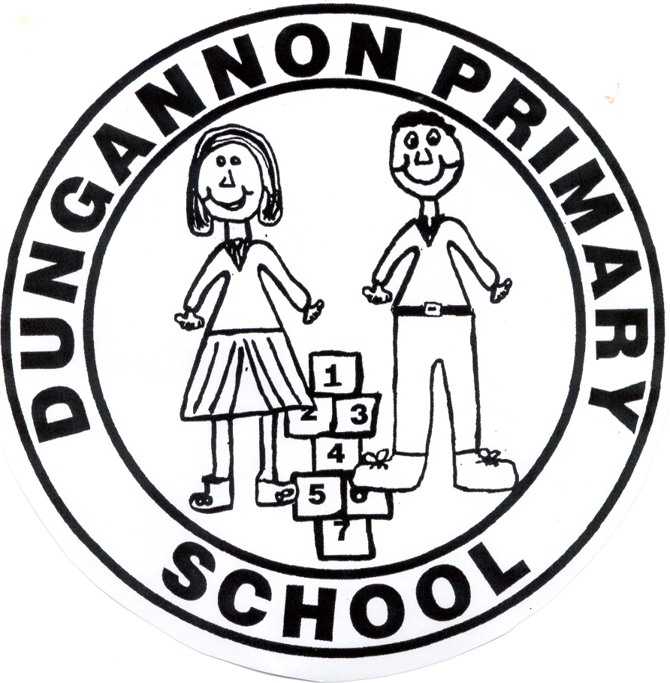

Anti-Bullying
Policy
Ratified by Governors: October 2021.
Reviewed May 2024.
Rationale
Bullying is in contravention of children’s rights to be protected from all forms of violence, both physical and mental. It infringes on their right to education and to freedom from torture and inhumane and degrading treatment under the Human Rights Act of 1998.

Addressing Bullying in Schools Act (NI) 2016 is the statutory guidance which is referred to by Dungannon Primary School and has been in operation from 01 September 2021. The Act creates the following statutory duties:
1. All grant-aided schools must have an Anti-Bullying Policy which is updated at least every 4 years.
2. Boards of Governors must determine and develop an Anti-Bullying Policy, ensure the policy is properly implemented and keep it under review so that it continues to be fit for purpose.
3. Schools must engage with pupils, parents/carers and the school community when they are developing and reviewing the Anti-Bullying Policy.
4. Schools must record incidents of bullying and alleged bullying behaviours including the motivation, method, how the incident was addressed and the outcome.

The Act should be read and understood in its wider legal and policy context, which is as follows:
Relevant NI legislation:
• The Children’s (NI) Order 1995
• The Education and Libraries (NI) Order 2003 Relevant Department of Education Guidance:
• Pastoral Care in Schools: Promoting Positive Behaviour 2001
• Measures to Prevent Bullying in DE Circular 2003/13
• Safeguarding and Child Protection: A guide for schools (2023)
• The United Nations Convention on the Rights of the Child (UNCRC)

Dungannon Primary School is completely opposed to bullying. It is entirely contrary to the values and principles by which we live and work. All members of this school community have a right to a safe and caring environment which is conducive to effective teaching and learning, free from intimidation and fear. They also have a responsibility to contribute in whatever way they can, to the protection and maintenance of such an environment. Bullying behaviour of any kind by any member of our school community to any other member of our community is completely unacceptable.

School Vision & Ethos Statement

Preparing Children, Enriching our Community, Shaping Futures.
At Dungannon Primary School, we endeavour to support, educate and cherish each and every child in a nurturing and inclusive environment where we celebrate our successes.

Mission Statement

Dungannon Primary School aims to provide high quality education in a happy and caring working environment, where the potential of each individual can be realised. Through the implementation of our Pastoral Care Policy, open lines of communication and consultation, we actively promote positive interpersonal relationships throughout our school community.
We believe that all members of staff have a right to work in, and pupils a right to learn in, a supportive, caring and safe environment, without fear of being bullied and so we do not tolerate bullying in any form

Principles underpinning Anti-Bullying Policy
- Pupils have a right to learn, and staff to work in, a safe, happy, secure environment, free of intimidation and fear.
- The needs of the victim are paramount.
- All reports of bullying behaviour will be taken seriously and thoroughly investigated.
- Positive self-esteem and a sense of self-worth, which will help them realize their physical, intellectual, social and personal potential, should be developed in all children.
- Children should be taught to become tolerant and understanding of others and to resolve conflicts with sensitivity.
- Anyone indulging in bullying behaviour must be helped to modify his/her behaviour.

What is Bullying?

School Definition of Bullying
Bullying is usually repeated behaviour that intentionally hurts, harms or adversely affects the rights and needs of another or others.

As a school community, we have sought to understand what bullying is and the different forms it can take. We understand that not all unacceptable, unkind and hurtful behaviour can be classed as ‘bullying’. The school will assess each Bullying Concern and will complete the Bullying Concern Assessment Form to identify if the behaviour is bullying or anti-social.

The legal definition of bullying for Northern Ireland as Outlined in the 2016 Act –
In this Act “bullying” includes (but is not limited to) the repeated use of -
a) Any verbal, written or electronic communication
b) Any other act, or
c) Any combination of those, by a pupil or group of pupils against another pupil or group of pupils, with the intention of causing physical or emotional harm to that pupil or group of pupils.
(For the purposes of subsection (1), “act” includes omission”).

Methods of Bullying

What is Emotional or Psychological Harm?
Emotional or Psychological harm occurs when an individual or group of people intentionally cause distress, anxiety, humiliation and impact negatively on the self-esteem of another individual.

What is Physical Harm?
Physical harm occurs when an individual or group of people intentionally cause injury such as bruises, broken bones or burns upon another individual.

The following methods can be described as, but are not limited to, saying, writing or using online contact and platforms to:
• say mean and hurtful things to, or about, others
• make fun of others
• call another pupil mean and hurtful names
• tell lies or spread false rumours about others
• try to make other pupils dislike another pupil/s
• extort from, blackmail or exploit another.

The use of electronic communication as a method of bullying behaviour is most commonly identified as cyber bullying. Cyber bullying is an aggressive, intentional act carried out by an individual or group against a target using, for example, electronic forms of contact and online platforms.

Other methods of bullying behaviour commonly include physical bullying and can be described as, but are not limited to:
• hitting
• kicking
• pushing
• shoving around
• locking a pupil/s inside a room, locker etc.
• material harm such as taking/stealing money or possessions
• other direct/indirect acts

The above behaviours can be one off acts or exclusionary behaviour. However, repetition of these behaviours is one way of establishing intention to harm, particularly if the bullying behaviours have not stopped after an intervention by the school.

The Act acknowledges that various methods of bullying behaviour can occur separately or together.

The Act specifies that methods of bullying behaviour include omission. This includes where a pupil is intentionally left out (e.g. ‘they stopped him playing with them’) and where there is a wilful failure to include a pupil (e.g. ‘they purposefully did not ask him to join the game’). Other examples include a pupil being excluded or left out of:
• a group of friends
• activities
• games
• group work in class
Exclusionary bullying behaviours are as serious as other verbal or physical acts. Bullying behaviours are not limited to repetition.

While repetition is internationally recognised as an important element in establishing bullying behaviour, The Act does not require repetition for behaviours to be defined as bullying.

It is important to note that one off incidents in certain circumstances may be treated as an act of bullying. When making this decision the school will consider the following:
- Severity and significance of the incident
- Evidence of premeditation
- Impact of the incident on individuals (physical/emotional)
- Impact of the incidents on the wider school community
- Previous relationships between those involved
- Any previous incidents involving the individuals
When alleged incidents fail to meet the criteria for bullying behaviour, the school will use their positive behaviour policy to address unacceptable behaviour.

Signs of Bullying
The signs below may indicate that a child is being bullied at school or while travelling to or from school during the school term. It is important to look for changes in behaviour patterns rather than jump to conclusions

Behavioural

- Unwilling to come to school
- Frightened of walking to or from school
- Comes late to school
- Avoids friends and others
- Performs poorly in class
- Poor concentration
- Continually loses money
- Refuses to tell anyone what is wrong
- Becomes emotionally volatile
Physical
- Frequently feels sick in class
- Has damaged clothes or belongings
- Socially isolated
- Has physical injuries which they are reluctant to explain
Emotional
- Becomes Withdrawn
- Startled easily
- Irritable and aggressive
- Loses confidence
- Burst into tears in class
- Becomes depressed
- Has low self-esteem

What can you do if you are being bullied? (Effective responses to Bullying Behaviour January 2022)
In class and in assembly children will be encouraged to deal with bullying in the following ways:
- Remember that your silence is the greatest weapon for a person displaying bullying behaviour.
- Don't put up with bullying behaviours
- Do
  - tell an adult, teacher, supervisor
  - tell your parents
  - keep away from the source of trouble
  - tell yourself that you do not deserve to be bullied - it is WRONG
  - be proud of who you are
  - try not to show that you are upset. A person displaying bullying behaviour thrives on your fear
  - stay with a group of friends/people. There is safety in numbers.
  - be assertive - shout "No". Walk confidently away. Go straight to a teacher.
- Teachers will take you seriously and will deal with individuals displaying bullying behaviours in a way which will end the bullying and will not make things worse for you.
What can you do if you know someone is the target of bullying behaviour?
- When someone is the target of bullying behaviour or is distressed - TAKE ACTION. Watching and doing nothing can suggest support for the occurring bullying
- Inform an adult e.g. teacher immediately
- Be kind and listen to the person who is a target of bullying behaviour
- Do not tolerate people who display bullying behaviour in your group of friends
- Don't ignore bullying - it won't go away.
- Don't be provoked into becoming involved.
As a Parent
- Always take an active role in your child's education. Enquire how their day has been, who they have spent their time with etc.
- If you feel your child may be a target of bullying behaviour, inform the school immediately. Your complaint will be taken seriously and appropriate action will follow.
- It is important that you advise your child not to fight back. It is important however to encourage your child to be assertive and resilient without the need for any physical retaliation or inappropriate verbal altercation.
- Assure your child that there is nothing wrong with him/her. It is not his/her fault that they are a target of bullying behaviour.
- Make sure your child is fully aware of the School's Anti-bullying policy and that they will not be afraid to report any bullying incident and ask for help.

PROCEDURE FOR DEALING WITH SOMEONE WHO IS A TARGET OF BULLYING BEHAVIOUR

- Listen carefully to what is being reported
- Remain calm and take the incident seriously
- Take action as quickly as possible
- Reassure the targeted person that the incident will be dealt with
- Record incident on bullying report form (Appendix 1) and inform Principal (Mr Thompson) who may refer to designated teacher for child protection (Miss Wilson)
- Parents of the child who is a target of bullying behaviour will be contacted when bullying has been identified and to inform them of the situation
- The Bullying Concern Assessment Form (BCAF) will be completed and updated accordingly
- Each teacher presents a number of strategies to provide a listening culture within their classroom. These may include ‘Worry Jar’ or ‘Worry Box’ Strategies and the timetabling of Circle Time sessions.

SUPPORT FOR THE INDIVIDUAL WHO IS A TARGET OF BULLYING BEHAVIOUR

- Teachers will raise self-esteem of a person who is a target of bullying behaviour eg. Constant praise, special duties
- Will be given time to discuss worries and concerns with class teacher and/or Principal
- Work with the pupil and identify SMARTE (Specific, Measureable, Achievable, Relevant, Timely and Evidence-based) targets, relevant success criteria, outcomes and assessment procedures
- Maintain dialogue to ensure identified strategies will result in greater resilience; development of new coping strategies and the promotion of positive restorative relationships
- Parents encouraged to give child more time
- Parents put in touch with outside agencies
- Collect data to evaluate the efficacy of the intervention
- Maintain staff and pupil self-assessment records

SUPPORT FOR THE PUPIL(S) DISPLAYING BULLYING BEHAVIOUR

- Work with the pupil and identify SMARTE (Specific, Measureable, Achievable, Relevant, Timely and Evidence-based) targets, relevant success criteria, outcomes and assessment procedures
- Maintain dialogue to ensure interventions/strategies identified will result in reduction/removal or unacceptable bullying behaviour/s; an enhanced ability to empathise and the restoration of relationships
- Incident when dealt with will not be referred to again
- Teachers will try to raise self-esteem of the person(s) displaying bullying behaviour
- Principal will take time to discuss issues
- Maintain staff and pupil self-assessment records
- Parents put in touch with outside agencies and given necessary advice
PROCEDURES FOR DEALING WITH INCIDENTS OF BULLYING

- A verbal reprimand will be given to the first minor incident of bullying but will include loss of privileges in school
- Pupil will lose their break-time or lunchtime play sessions for further incidents or more serious incidents. A constructive task relating to bullying will be given. (The Principal will record in incident book and may phone or write a note home if appropriate)
- The Bullying Concern Assessment Form will be updated accordingly
- Parents of pupil(s) displaying bullying behaviour will be notified and if necessary asked to come into school for a meeting.
- External agencies will be contacted in line with our Child Protection Policy if bullying persists.
- If bullying continues, suspension for a fixed time in accordance with school discipline policy
- If such behaviour does not end, they will be recommended for permanent exclusion (expulsion) in accordance with EA policy.
It is anticipated that steps 6 and 7 will only be carried out in exceptional or persistent cases and will be executed in line with EA procedures.

(ALL THESE STEPS WORK HAND-IN-HAND WITH THE SCHOOLS’ POSITIVE BEHAVIOUR POLICY)

Through both the school’s pastoral care and curricular activities the school sees
the following longer term preventative strategies being employed.

- Heighten awareness among staff, parents and all others involved in school that Dungannon Primary School operates a zero tolerance approach to bullying behaviour
- Monitor and evaluate our anti-bullying policy and procedures on a regular basis grounded in the belief that it is a living working process which needs to be regularly reviewed and updated.
- Establish a climate in which it is safe to “tell” – a “listening, caring, telling” school where children are reassured that action follows telling. (Onlookers will also be encouraged to be responsible for making good choices – the school recognises that the person who is displaying bullying behaviour can often have group support and that onlookers may be afraid to tell or interfere because they fear retaliation)
- Actively promoting a listening school – giving pupils a voice (to include school contract/ open door policy/ class meetings.)
- Bullying hotspots will be identified and risks minimised.
- The school will give its anti-bullying stance a high profile e.g. No Bullying Here posters, Anti-bullying Week and specialised assembly)
- Focus on bullying at a whole school level through assemblies etc to promote a High Five Approach to stop bullying e.g.
(i) tell someone
(ii) ignore them, walk away
(iii) be strong – act confidently – ‘Say No’ , ‘Go Away’
(iv) avoid being nasty back
(v) stay calm
- Promotion of children’s personal, social and emotional development through a pastorally infused curriculum facilitated through the Personal Development and Mutual Understanding area of learning. This may include the following:
- self-esteem building through circle time
- exploring feelings through the Living Learning Together Resource
- drama role play – exploring others point of view
- group problem solving approaches
- cross curricular learning – eg: Bullying Rap in Literacy etc…..
- Ongoing staff development to ensure a shared understanding of the nature and extent of bullying in school and appropriate prevention/intervention practices.
- Good classroom management with appropriate rewards and sanctions.
- An efficient record keeping system.
School will work closely with bus drivers and bus companies to address bullying issues and prevent similar incidents re-occurring in the future.
Teachers will work hard with pupils to ensure they demonstrate exemplary behaviour when walking to and from school during the school term.
School will work and support pupils who demonstrate bullying behaviours or who are being bullied.

Our school will take the following measures to prevent cyber-bullying outside of school:

Children should know that they are responsible for making an Acceptable Use of the Internet. They must discuss and agree rules for this Acceptable Use. Parents are also asked to be aware of the code of Acceptable Use and confirm that their children will follow these rules.

- On the network, I will only use my own login username and password.

- I will keep my username and password private.

- I will not access other people’s files without their permission.

- I will not change or delete other people’s work/files.

- I will ask permission before entering any website, unless my teacher has already approved that site.

- I will use the Internet for research and school purposes only.

- I will only send e-mail which my teacher has approved. I will make sure that the messages I send are polite and responsible.

- I understand that the use of strong language, swearing or aggressive behaviour is not allowed when using e-mail etc.

- When sending e-mail I will not give my name, address or phone number or arrange to meet anyone.

- I understand that I am not allowed to enter Internet Chat Rooms while using school computers.

- If I see anything I am unhappy with or I receive messages I do not like, I will tell a teacher immediately.

- I will not bring in memory sticks or CD Roms from home to use in school unless I have been given permission by my class teacher.

- I understand that the school may check my computer files/Emails and may monitor the Internet sites that I visit.

- I will always quote the source of any information gained from the Internet i.e. the web address, in the documents I produce.

I understand that if I deliberately break these rules I could be stopped from using the Internet/E-mail and my parents/carers will be informed.

It is important to note that all socially unacceptable behaviours will be dealt with in line with the school’s Positive Behaviour Policy’s Procedures.

It is important to note that this policy applies when:
- A child is travelling to school on the school bus/taxi
- A child is walking to/from school
- A child is on the school premises (including playground and grass pitch)
- A child is participating in external events i.e. swimming, school trips

Links with other Policies –
- Positive Behaviour Policy
- Safeguarding and Child Protection Policy
- Health & Safety Policy
- Special Needs Policy
- Safe Handling/Reasonable Force Policy
- E-Safety Policy
The above Policies can be obtained from the school upon request.

Maintaining effective links with external support agencies eg.
- Behavioural Support Team
- Education Welfare Officer.

PUBLICISING THE POLICY

Parents are informed of the anti-bullying policy through the school’s induction process. Parents are freely available to request a copy of the school’s policy at any time. This policy will be updated and kept on the school website.

Teachers and other staff will follow agreed procedures to prevent and investigate bullying. Pupils are carefully supervised at all times.

It is the responsibility of the Board of Governors and Principal to monitor the effectiveness of the Anti-bullying policy. They will use performance and other data to:
- determine how effective the school’s preventative measures are in reducing: levels of and opportunities for bullying behaviour; severity and frequency of incidences by noting reductions/increases; monitoring response times, etc.
- identify patterns and trends: evaluate reporting and recording procedures; measure impact on levels of achievement; evaluate efficacy of the interventions and the support provided
- determine how effective the policy’s processes are in: identifying underlying motivation; promoting and maintaining restoration
- ensure that the policy through consultation and participation is successfully identifying current needs and addressing them appropriately
- inform and guide policy development and review through feedback received from baselining surveys with parents/carers, staff, Governors and pupils
- ensure that policy concerns are identified quickly and addressed through the ongoing School Development Planning process
Governors will ensure that all incidents of bullying are recorded. It is important that a fully transparent system is established so that reported incidents can be taken forward in line with the school policy and be traced through the system as having been resolved by the school.

The preventative measures will be reviewed by the Board of Governors at intervals of no more than 4 years. Anti-bullying will be a standing item on the agenda of each Board of Governors meeting. A report of the numbers of incidents of bullying, including method, motivation and how the incident was addressed will be presented at each meeting.

Signed Principal:

Date

Signed Chair of Governors:

Date
APPENDIX 1

ANTI-BULLYING INCIDENT REPORT FORM

Name: __________________________
(Person who is the target of bullying behaviour)

Name: ___________________________
(Person who is displaying bullying behaviour)

Date: __________________________________

Description of incident:

Action taken:

Signed: ____________________________________ (Member of staff)

Signed: ____________________________________ (Principal)

